1. **Agenda**:
   1. We’re going to create a Node.js App.
   2. You can skip it.
2. 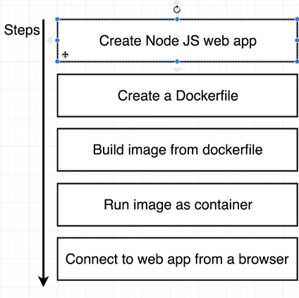
3. 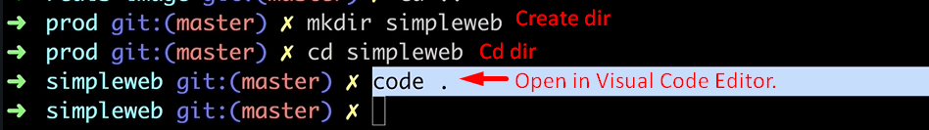
4. 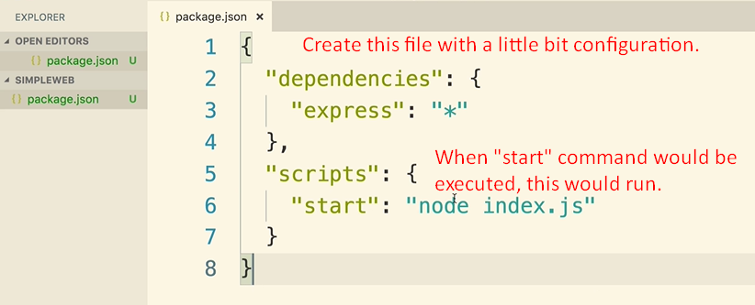
5. 